Menu Setting

HRMS

V0001.1

 | Name | Role | Signature | Date
Author | Ramu Nunna |  | Developer | 18/09/2015
Reviewer
Approver

Table of Contents
1. Introduction 3
1.1. Purposes 3
1.2. Scope 3
1.3. Audience 3
1.4. Reference 3
2. Functional Overview 3
2.1. Major Functions 3
2.2. Functions Out of Scope 4
2.3. Assumptions / Constraints / Dependencies (A /C /D) 4
3. Functions 5
3.1. Common function 5
3.2. Event Log Screen 6
3.3. Set Date 9
3.4. Key Result Objectives 12
3.5. Objective Set Review 15
3.6. Objectives Vs Results 18

Introduction

Purposes

The purpose of this document is to define the Menu setting module functionality, which should be integrated with SmartHR. This document aims to capture all roles and access of each role information.

Scope

The scope covers the entire Menu configuration functionality as given below

- Capturing the modules.
- Capturing the parent menu,child menu & sub child menu with order.
- Adding menus role wise.
- Give access Branch wise

Reference

Requirement document of NH shared by Braj mohan das (BA).

Functional Overview

Major Functions

Firstly we alerday to created modules ,parent menus,child menus, subchild menus . Depending upon the role we need to assign required menus. We can create unlimited roles in this application . After that depending our requirement we need add that menus particular role. Super admin has all rights to to any changes in through out application. According this application they have Superadmin , HR,HOD and User roles.

Super Admin :
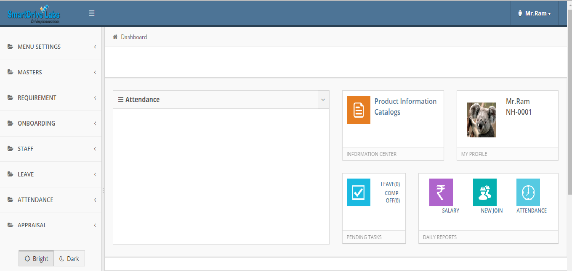

Principal

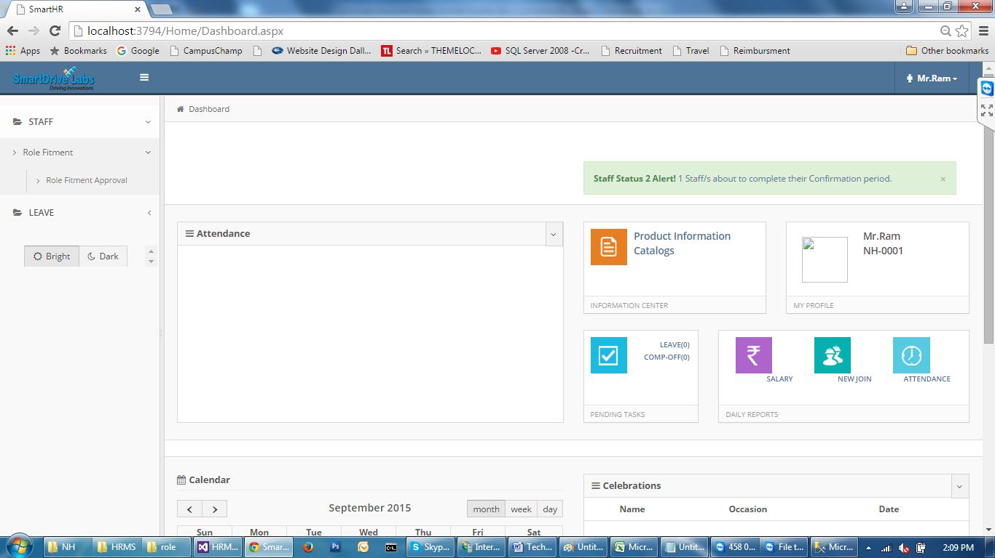

HOD :
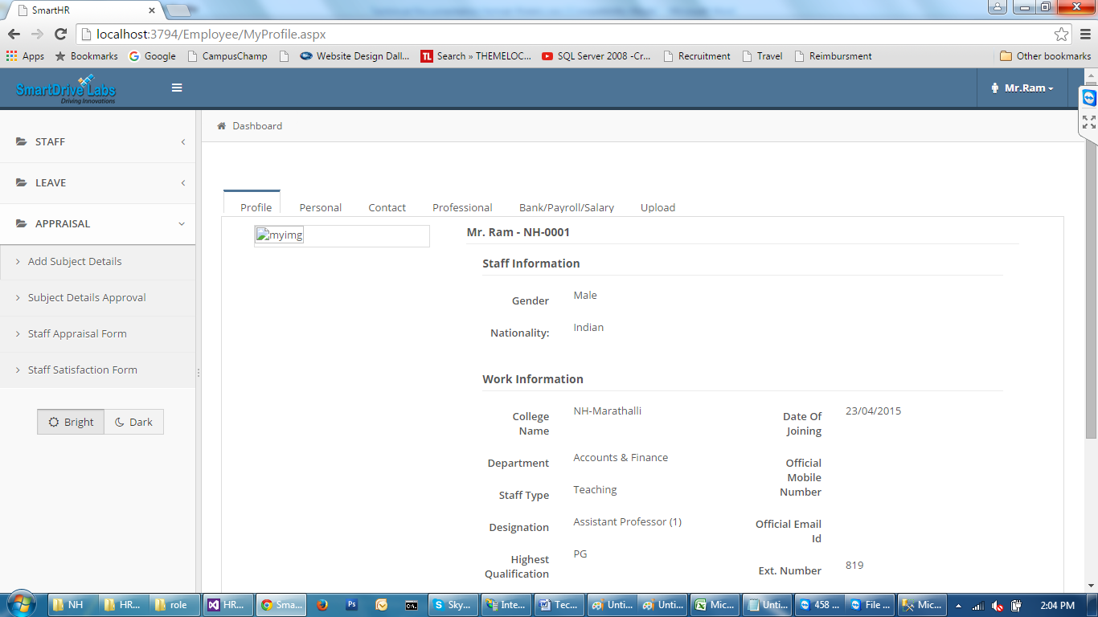

HR :

User :

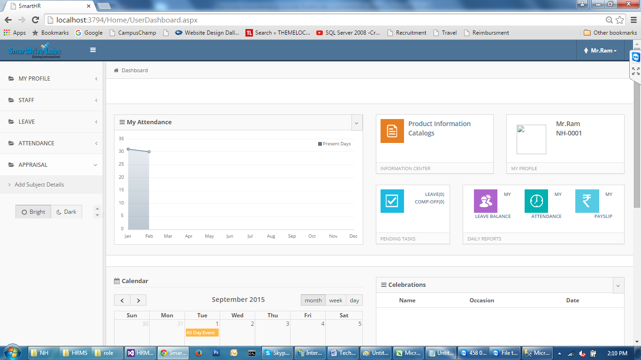

Functions Out of Scope

N A

Assumptions / Constraints / Dependencies (A /C /D)

Description of Assumptions / Constraints / Dependencies
Assumptions | - Menu has to assign before go to application
Constraints | N A
Dependencies | - It has dependency on all modules.

Functions

Common function

Sr. No. | Function Name | Purpose
 | Employee listing | Employee selection window to select employees. This by default has a search option too.
 | Validations | We need to use common alert function.

Code
We are using bootstrap technique for front end designing. For connection SQL server to VS studio we are using ADO.net .

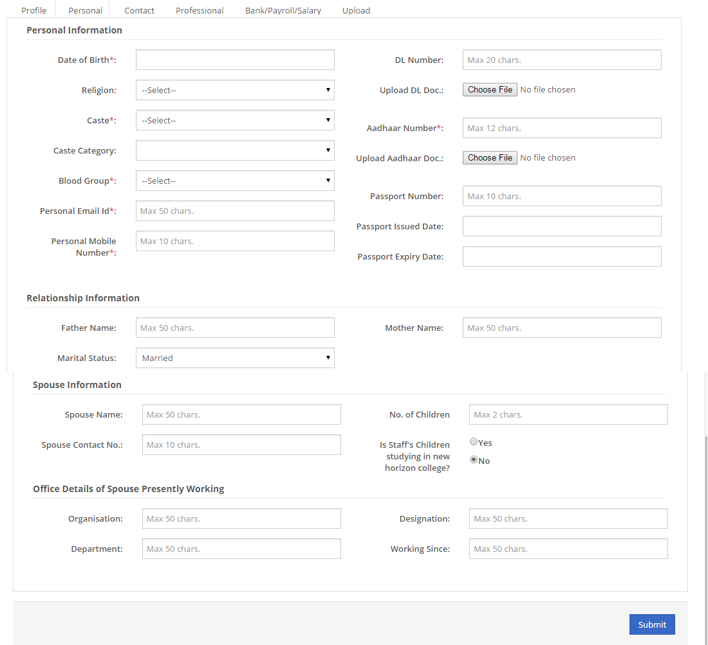

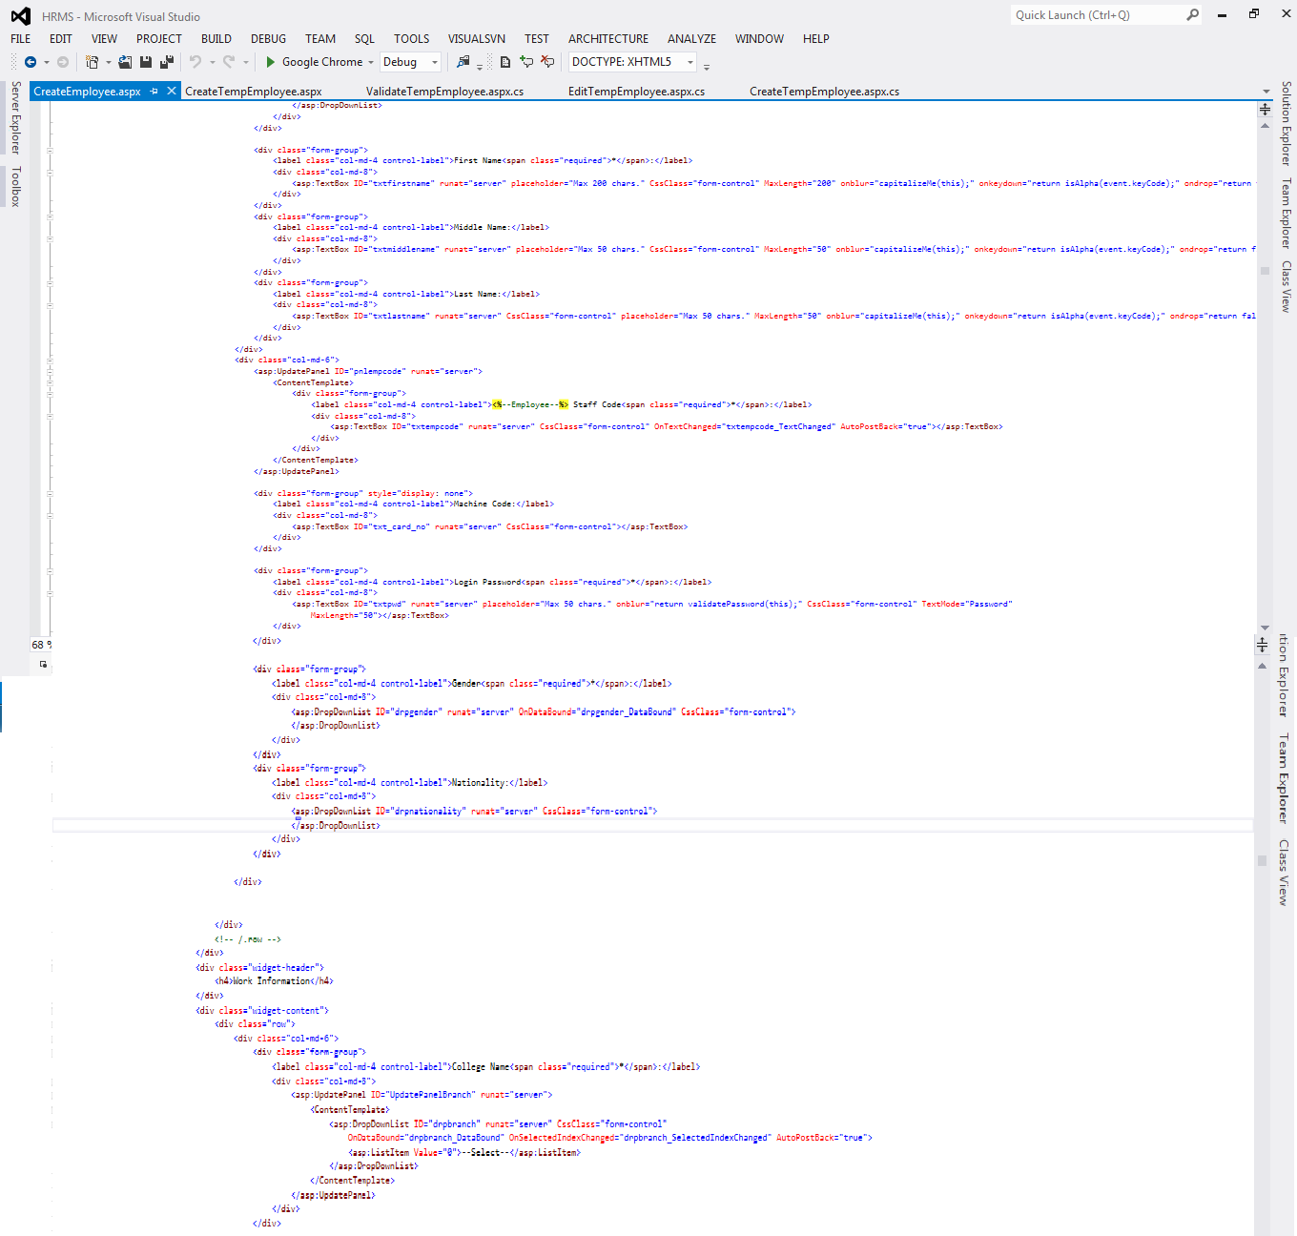

1. Open connection
2. Send parametes using sqlparmeter[].
3. Send command type (Text,Storedprocedure)
3.Close connection

For Insert we are using ExexuteNonQuery.
For showing data we are using ExecuteDataSet.
For getting insert column ID we are using execute scalar.

By using dataset we are manipulate data then we are display in grid view. For data manipulation in servere we are using sqltransaction, why because any error occure between transaction it will roll back that process.

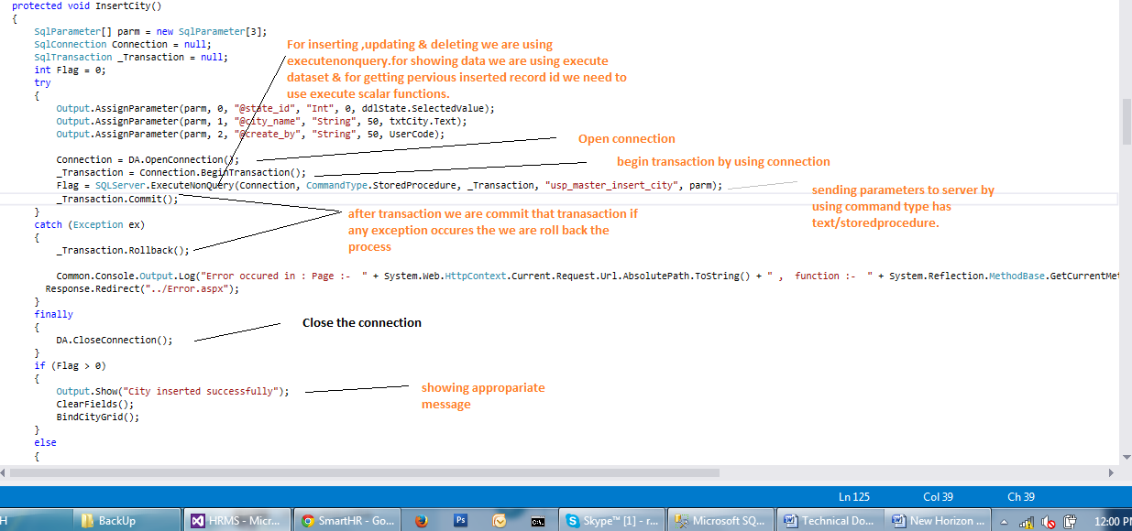

Error Handling :

By using try ,catch & finally we are handling error. By using common log function we capturing error.
We are creating error folder in current source code path with date wise it will show. In that we are showing which page,which function error is occurring and what is error and which time it is occur. By using this we can find error easily.
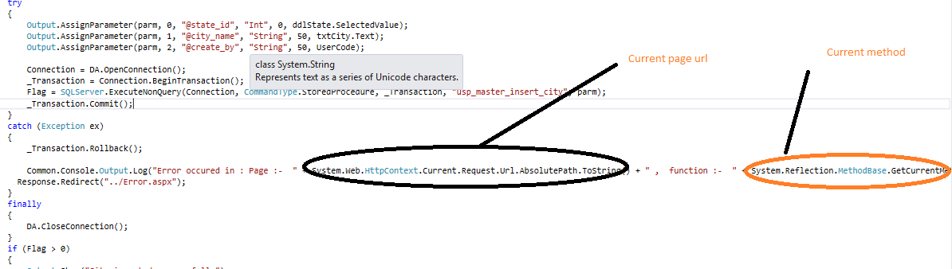

Database Architecture

Database Fields along with table structure.

module
menumaster
rolemenu
rolebranchmapping
dbo.module

Sr No | Entity | Description | Type | Length
 | modulecode | Identity the identity column. | Int | -
 | company_id | Identifying which company | Int | -
 | modulename | Name of module | VarChar | 50
 | status | Identitify active or inactive | Bit | 1
 | create_date | Identifying when created this record | Datetime | -
 | create_by | Identifying who created this record | VarChar | 50
 | update_date | Identifying when updated this record | Datetime | 50
 | updated_by | Identifying who updated this record | VarChar | 50
 | mod_order | It will show order of module | Int | -

Database Design
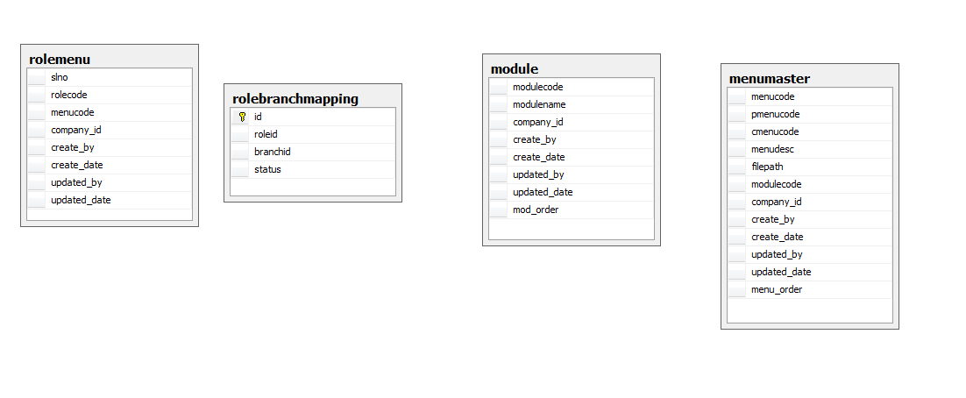
Server Function Design
- Register
Client to Server : user name, password Server to Client : Success / Fail, Error message
Action on Server : create employee
- Login
Client to Server : user name, password
Server to Client : Success / Fail, Session id / Error message
Action on Server : verify user name & password
set session id of user
- Logout
Client to Server : user name, Session Id
Server to Client : Success / Fail, Error message
Action on Server : clear session id & session expire time

